

# Namibian Summer x 2

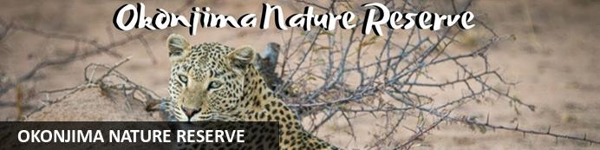

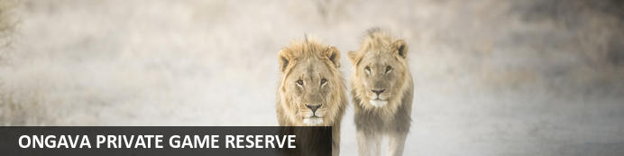

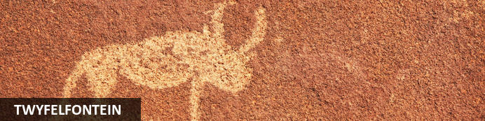

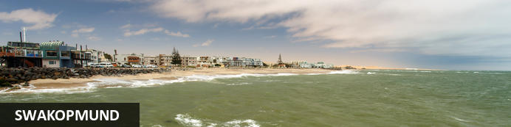

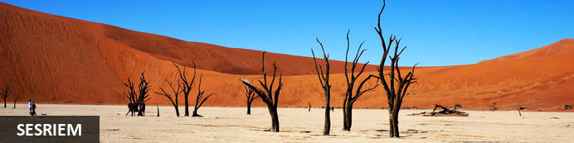

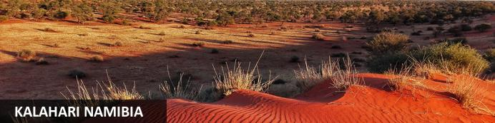

# Namibian Summer x 2

*Okonjima Nature Reserve - Ongava Private Game Reserve - Twyfelfontein - Swakopmund - Sesriem - Kalahari Namibia*  
*10 Days / 9 Nights*  
*2 Persons*  
*Reference:*

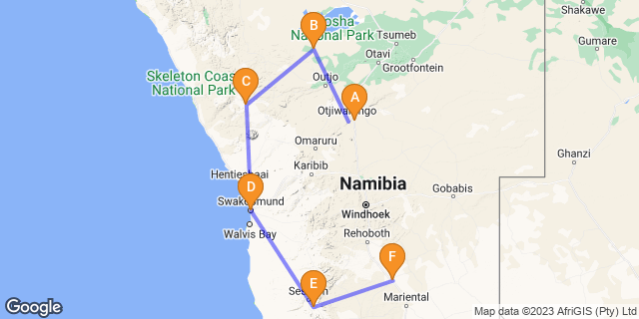

## Introduction

|  |  |  |  |  |  |
| --- | --- | --- | --- | --- | --- |
| **Accommodation** | **Destination** | **Start** | **End** | **Basis** | **Duration** |
| Okonjima Luxury Bush Camp | Okonjima Nature Reserve |  |  | FB+ | **1 Night** |
| Anderssons At Ongava | Ongava Private Game Reserve |  |  | FI | **2 Nights** |
| Mowani Mountain Camp | Twyfelfontein |  |  | D,B&B | **1 Night** |
| Strand Hotel Swakopmund | Swakopmund |  |  | B&B | **2 Nights** |
| Namib Outpost | Sesriem |  |  | D,B&B | **2 Nights** |
| Kalahari Red Dunes Lodge | Kalahari Namibia |  |  | D,B&B | **1 Night** |

**Key**  
B&B: Bed and Breakfast. D,B&B: Dinner, Bed and Breakfast. FB+: Full Board Plus - Dinner, Bed, Breakfast, Lunch and Activities. FI: Fully Inclusive - Bed, All Meals, Fees and Activities

## Included

Emergency Medical Evacuation

Info Packs VIP Groups

## Per person sharing NAD: 135,000.00

## Day 1: Okonjima Luxury Bush Camp, Okonjima Nature Reserve

### Okonjima Nature Reserve

Halfway between Windhoek and Etosha lies the well-known Okonjima Nature Reserve. The 22 000 ha Nature Reserve is surrounded by 96 km of fence and was finally completed in 2010. Okonjima is home to AFRICAT, a Carnivore Conservation, which gives the captive carnivores a second chance to be released back into the wild and to take the time it needs, to become a completely independent hunter - in a protected area right in the middle of commercial farmland! Also in the Reserve is a 2000 ha 'safe' zone around Plains Camp, Bush Camp, Bush Suite, the Omboroko Campsite as well as the PAWS Environmental Education Centre.

### Overnight: Okonjima Luxury Bush Camp

The elegant Luxury Bush Camp is situated within the 2 000-ha enclosed wilderness area of Okonjima Nature Reserve, only 2.5 km from the Okonjima Plains Camp.  
The Luxury Bush Camp consists of 8ight thatched, African-style chalets, a junior suite and three en-suite safari tents for pilots & guides.

The Luxury Bush Camp consists of:

Eight thatched, safari-chic chalets with earthy tones and African design elements.  
Each of the private chalets are between 80-100 metres away from one other.  
The junior suite.  
A Camelthorn pod-shaped lapa that encompasses the reception area, curio shop, a cozy lounge area with inside and outside fireplaces, a restaurant and dining area. It looks out onto the waterhole.  
A secluded, private swimming pool.  
A Wi-Fi hotspot and has cellphone reception as well as undercover, private parking.

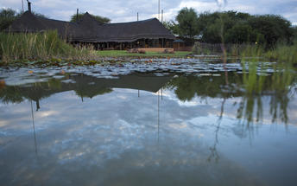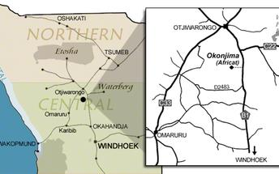

### Basis

Full Board Plus - Dinner, Bed, Breakfast, Lunch and Activities

## Day 2: Anderssons At Ongava, Ongava Private Game Reserve

### Ongava Private Game Reserve

Sharing a common boundary with Etosha National Park, the prolific 30 000-hectare private Ongava Game Reserve is considered one of the finest private game reserves in the region, enjoying global recognition for exceptional conservation, ground breaking research and exciting safari experiences. The reserve is home to – among others – lion, eland, black-faced impala, Hartmann's mountain zebra and a variety of other antelope species. Additional, it is one of the few private reserves in Southern Africa where both black and white rhinos can be observed. The recorded bird life has reached over 340 species. Each Ongava property has its own unique style, layout and atmosphere; but all offer the same wonderful sense of luxurious seclusion. Built from local materials in traditional fashion, they blend tastefully into the surrounding landscape, allowing visitors to feel at one with nature. Spacious lounge areas, reflecting the colours and textures of the African bush, invite guests to relax, enjoy a drink from the bar, or simply gaze out into the distance and be surprised as Ongava’s spectacular wildlife emerges from the bush. Every guest suite is individually designed for quality and comfort, and our dedicated guides and catering staff are always available ensuring an unforgettable Ongava stay.

### Overnight: Anderssons At Ongava

With pressing environmental issues threatening our future, Ongava is once again responding to the  
needs of the planet and our guests with the creation of Anderssons at Ongava and the Ongava Research Centre (ORC), the next generation in eco-tourism.

Taking a lesson from the wild in the power of symbiotic relationships, Anderssons at Ongava provides an interactive hub for guests to be a part of conservation science, where cutting edge technology meets hands on, field-based research.

Guests at Anderssons at Ongava have the option of being immersed in and can contribute to developing creative, knowledge driven solutions with resident scientists, visiting researchers, conservationists and rhino security personnel, or simply relaxing and enjoying the luxurious guest suites, waterhole, viewing hide, and pool where they will find their own personal place for reflection.

Ensuring a light footprint and an exceptional experience, Anderssons at Ongava will have seven  
contemporary designed luxury guest units and one family unit, accommodating a maximum of 18 Guests.

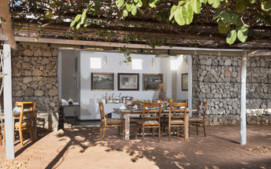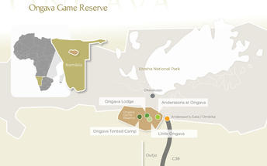

### Activities

|  |
| --- |
| Anderssons at Ongava - Game drives on Ongava Game Reserve |

#### Anderssons at Ongava - Game drives on Ongava Game Reserve

Guided morning and afternoon game drives take place on the private Ongava Game Reserve.

Situated at the border of Namibia’s most important private game reserves, and in the privately owned Ongava Game Reserve – one of the largest private game reserves in Namibia.

Game drives at Ongava can be either within the private reserve or in Etosha.  The Ongava Private Game Reserve has a healthy population of lion, black and white rhino, elephant, giraffe and several species of antelope, including the rare black-faced impala.

Ongava’s experienced rangers are carefully selected, fully trained in first aid and firearms use, and look forward to sharing their in-depth knowledge of the wildlife and the land that is part of their natural heritage.  Their passion for the wild is contagious.

### Basis

Fully Inclusive - Bed, All Meals, Fees and Activities

## Day 3: Anderssons At Ongava, Ongava Private Game Reserve

### Activities

|  |
| --- |
| Anderssons at Ongava - Excursions into Etosha National Park |
| Anderssons at Ongava - Guided Nature Walks |
| Anderssons at Ongava - Hide |

#### Anderssons at Ongava - Excursions into Etosha National Park

Full- or half-day guided morning and afternoon game drives in Etosha, Namibia’s prime savannah wilderness area allow you to see the massive saltpan as well as perennial springs that provide the water required by the Park’s high-density big game population. Full day activity on request and comes with packed lunch.

#### Anderssons at Ongava - Guided Nature Walks

Offered seasonally and subject to an available walking guide, nature walks through the area take in the abundant array of life, from unusual plants to arid-adapted animals.

#### Anderssons at Ongava - Hide

Andersson’s hide allows for unobtrusive game viewing of the camp’s waterhole. Often frequented by plains game including warthog, zebra, giraffe and an array of antelope, the waterhole also attracts larger game such as rhino and sometimes even lions.

### Basis

Fully Inclusive - Bed, All Meals, Fees and Activities

## Day 4: Mowani Mountain Camp, Twyfelfontein

### Twyfelfontein

Twyfelfontein is a site of ancient rock engravings in the Kunene Region of north-western Namibia.

### Overnight: Mowani Mountain Camp

Mowani Mountain Camp offers luxury tented accommodation with magnificent desert views. Open air en-suite bathrooms and private decks give you great views of Damaraland and the reliability of nearby Twyfelfontein with its San engravings and paintings is contrasted by the elusive desert adapted elephants.

The Twyfelfontein conservancy has been protecting the southern most roaming ground of the black rhino and elusive desert elephant. Sustainable eco-tourism and community upliftment is of the utmost importance at Mowani. Guides from the local tribes compliment day-time game drives to track mountain zebra, kudu, springbok, klipspringer and if you are fortunate enough... the leopard! The adventurer in me took over at Mowani. Days were filled with game drives, hot air balloon trips over the Aba-Huab Valley, champagne breakfasts and al fresco meals amidst the dusky landscape beneath Mopani trees.

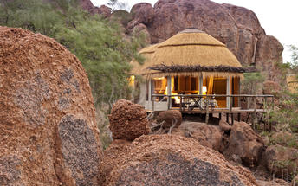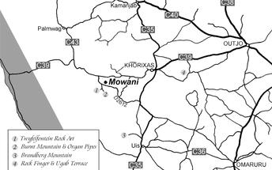

### Activities

|  |
| --- |
| Omutima Himba Village Visit |

#### omutima himba village

The Himba are an indigenous people with an estimated population of about 50,000 people living in northern Namibia, in the Kunene Region (formerly Kaokoland) and on the other side of the Kunene River in southern Angola. There are also a few groups left of the OvaTwa, who are also OvaHimba, but are hunter-gatherers. Culturally distinguishable from the Herero people, the OvaHimba are a semi-nomadic, pastoralist people and speak OtjiHimba, a variety of Herero, which belongs to the Bantu family within Niger–Congo. The OvaHimba are semi-nomadic as they have base homesteads where crops are cultivated, but may have to move within the year depending on rainfall and where there is access to water. The OvaHimba are considered the last (semi-) nomadic people of Namibia.

### Basis

Dinner, Bed and Breakfast

## Day 5: Strand Hotel Swakopmund, Swakopmund

### Swakopmund

Germany’s North Sea and Baltic coasts transplanted onto African soil. But the city is also thoroughly African and its multidimensional appeal means that most people end up staying longer than they planned.

Palm-lined streets, seaside promenades, fine accommodation, a pleasant summer climate and decent beaches. During the summer holidays and long weekends, thousands of Namibians flock to the coast, and this human migration happens for a number of reasons; Swakopmund has a real holiday feel to it and everyone wants to be there; during the December holidays, the cool Namibian coast offers relief from the intense heat of the interior; and more importantly as far as the tourist is concerned in these modern times, Swakopmund has changed, and has become the country’s leading adrenaline destination, with a wide range of activities to suit all ages.

The area of Namib Desert around Swakopmund is named the West Coast Recreational Area and recreation is the towns number one draw card. There are countless pursuits to help you spend your time, and money. For those interested in adventure activities Swakopmund offers sandboarding, quad biking, dune carting, parachuting, hot air ballooning, shark fishing, deep sea fishing and beach angling to name but a few. For the more sedentary there are restaurants, cafes, art galleries, the Swakopmund Museum, a snake park and aquarium.

Buildings and monuments of note in Swakopmund include the Hohenzollern Building, the Marine memorial, the War memorial in memory of those killed in World War 2, Princess Rupprecht House originally a military hospital now a private guest house, the Kaserne buildings that originally served as a barracks and is of a similar design to the Alte Feste in Windhoek and Fort Namutoni in Etosha. The old Swakopmund Prison is still fully operational and provides budget accommodation for the criminal fraternity of the Namibian coast.

The Swakopmund Railway station was completed in 1901 and now houses the Swakopmund Hotel, while the bells of the Deutsche Evangelical Church were imported from Germany. Standing close to the State House (Kaiserliches Bezirksgericht) is the Swakopmund Lighthouse at just over 20 meters it has been functional since 1902.  
  
The main beach area is called the Mole, and is the result of a largely unsuccessful attempt to construct the artificial harbour (as South Africa owned the only natural harbour in the area at Walvis Bay). The town’s most iconic symbol is the Swakopmund jetty, initially used as mooring for ships it later became a popular are for anglers and walkers, it has fallen into disrepair on numerous occasions and has been subject to several attempts to rescue it from complete dereliction. Recently large scale work has been completed on the jetty which now proudly boasts a small restaurant and bar area.

True to its German traditions early mornings and evenings in Swakopmund can be cold throughout the year, as the cold Atlantic Ocean meeting the Namib Desert creates a fog bank. This coolness is often a relief from the heat of the rest of Namibia, but does mean that Swakopmund is not the tropical sunbathing mecca that most people imagine.

### Overnight: Strand Hotel Swakopmund

With its extensive, unique and creatively entertaining Restaurants, Bars, Deli, Lobby-Lounge, Sea Facing Terraces, Beach Kiosk and state of the art Conference & Banqueting Center, all set on the Mole, a historic and iconic site surrounded by Ocean on three sides, the Strand Hotel Swakopmund is a social epicenter and destination in itself for all visitors to and residents of Swakopmund. Its architectural inspiration finds its roots deep in Namibian German history and reflects this in a tasteful contemporary manner. The interiors are residential in nature, and the brief to all designers involved was to create a non-hotel, hotel. One as charming and welcoming as the town it is located in. Simply very warm and comfortable, and as they say in German: “gemütlich” providing a genuine “sense-of-place” atmosphere adding to any Namibian visit. Arriving at the Strand is a dramatic experience as one passes through its 13m high and 9m wide Ocean View Atrium which travels right through the Hotel offering sea views at either end. Off this Atrium Lobby is Reception, consisting of three individual desks and an inviting open fireplace which rounds off the residential feel and warm welcome.

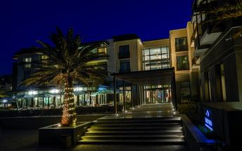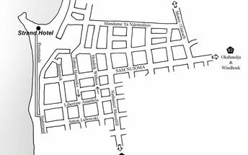

### Basis

Bed and Breakfast

## Day 6: Strand Hotel Swakopmund, Swakopmund

### Activities

|  |
| --- |
| Combo Tour: Dolphin Cruise & Sandwich Harbour |

#### Combo Tour: Marine Cruise & Sandwich Harbour

COMBO TOUR: MARINE CRUISE & SANDWICH HARBOUR With the Marine / Dune Combo two popular tours into one tour that last approximately 8 hours of which 2½ hours would be on board our wide body catamarans for our popular Dolphin Cruise. This tour is recommended as a full day activity as you get to experience the best of both worlds. The tour will take you past all the interesting and fascinating places of the Walvis Bay Harbour and lagoon, enjoy the antics of bird dolphins and seals around the boat as they compete for a snack and the scenery as we sail past amongst and oyster farm, bird island and more. Lunch is served either on the boat or in the desert. Thereafter, We head out south towards the dunes and Sandwich harbour, in 4x4 vehicles. Arriving at Sandwich Harbour we will stop on top of the dunes so that you can enjoy the breath-taking views of the desert.

### Basis

Bed and Breakfast

## Day 7: Namib Outpost, Sesriem

### Sesriem

As there is no accommodation at Sossusvlei, visitors to this desert wilderness are likely to end up staying at Sesriem, 65 kilometres away, where camps and lodges serve as a base from which to explore the dunes. Sesriem Canyon, a deep chasm carved through the rocks by water, is a striking natural feature of the area that is best explored on foot. Stony walls rise up sharply on both sides of the canyon, while birds roost in its crags and lizards dart along the ledges. The canyon’s name was coined when early settlers used it as a water source, using six lengths of leather (‘ses riem – six thongs) tied together to lower buckets into the water at the base of canyon.)

### Overnight: Namib Outpost

Deep in the Namib Desert, at the foot of a mountain, the lodge overlooks a plain all the way to the red dunes of Sossusvlei and the mountains of the Naukluft. Each chalet is a retreat that allows a true encounter with the desert, shielded from view from other houses.

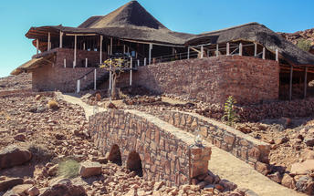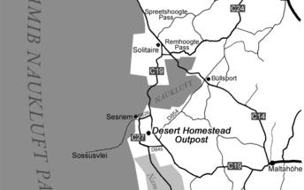

### Activities

|  |
| --- |
| Sundowner Drive |

#### Sundowner Drive

Afternoon game drives in open four-wheel-drive vehicles are offered at all the Ondili lodges. An experienced guide will point out the special features of the area and provide interesting facts about nature. Game sightings are almost guaranteed and the driver definitely knows the most beautiful spot for a sundowner. You will be back at the lodge in time for dinner.

### Basis

Dinner, Bed and Breakfast

## Day 8: Namib Outpost, Sesriem

### Activities

|  |
| --- |
| SOSSUSVLEI EXCURSION |

#### SOSSUSVLEI EXCURSION

Join a guided tour of approximately six hours which includes Sossusvlei, Dead Vlei and the possibility to climb a mighty dune called Big Daddy.

The excursion starts before dawn at Desert Homestead Lodge or Namib Outpost with an early bird breakfast. We use closed body 4×4 vehicles to negotiate the challenging sandy sections in Namib-Naukluft National Park.

We arrive at Sossusvlei well before sunrise. The guides will tell you many fascinating details about the desert and its inhabitants. An unforgettable experience will be the red dunes of the Namib Sand Sea, a World Heritage Site.

We return to the lodge early afternoon.

### Basis

Dinner, Bed and Breakfast

## Day 9: Kalahari Red Dunes Lodge, Kalahari Namibia

### Kalahari Namibia

The Kalahari is an exceptionally beautiful living desert a large semi-arid sandy savannah draped over a gently rolling inland sea of sand covering most of Botswana and large parts of Namibia and South Africa.

### Overnight: Kalahari Red Dunes Lodge

KALAHARI RED DUNES LODGE, a lodge designed with a lot of passion for details, is located in the impressive Kalahari landscape characterized by red sand dunes and camel thorn trees. Its “Luxury of Solitude”, offers ample space and privacy.

The main house, consisting of reception, lobby, restaurant and bar, pool and shaded deck is situated in a dry lake (vlei). A wooden boardwalk connects the main building with the chalets which are nestled around the ‘vlei', where often animals can be observed. Each chalet has a thatched roofed tented and a stoned section as well as a private terrace. During the Nature/ Game Drives and nature walks guests can experience the breathtaking beauty of the Kalahari with it’s up to 30 m high red dunes and a huge variety of game.

The suites with their thatched roofs are each decorated in an individual style and are connected to each other by a paved walk-way.

The vastness of the African Savannah can be experienced on the 2-day TRANS KALAHARI WALK. This guided hike leads through desert-like sceneries and their habitat of giraffes, zebras and antelopes and offers one overnight stay in a luxury tented camp in the dunes.

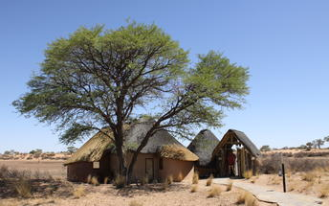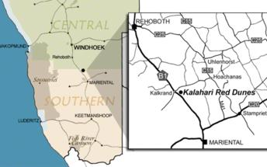

### Activities

|  |
| --- |
| 3-4 hour Sundowner Drive including Drinks |

#### 3-4 hour Sundowner Drive including Drinks

Top your Red Dunes day with our Sundown Drive. Enter the sunset in our open off-road car with expert guidance. Immerse in this most beautiful hour of the Kalahari desert.

### Basis

Dinner, Bed and Breakfast

## Day 10: End of Itinerary